**OUTPUT OF THE TASK:**

Table Output:

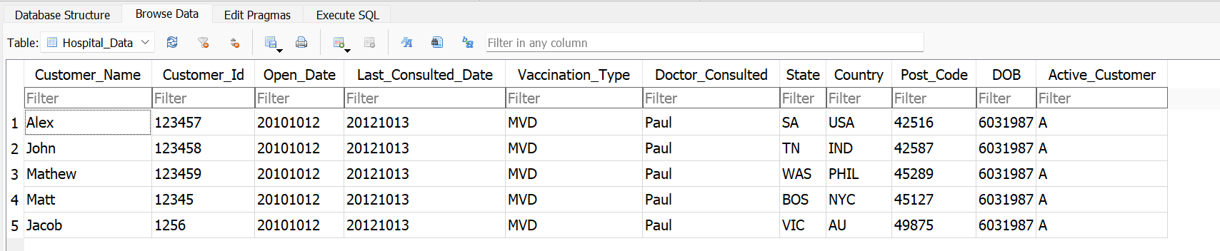

Each Country Table:

